1. Actor.

The below diagram describes all actors of the Mobile Phone - Store Management System. An actor represents a User Role; currently we have Administrator and Normal User Account. Each user has his own actions when accessing into the system.

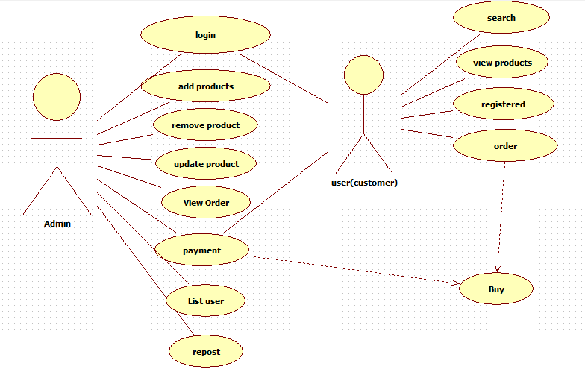

# System Use Case Diagram

The following diagram provides an overall picture of the functionality groups, Actors of the Mobile Phone - Store Management System. Mobile Phone - Store Management System’s functionalities are divided into these use cases:

* 1. Manager System - Use Case Diagram

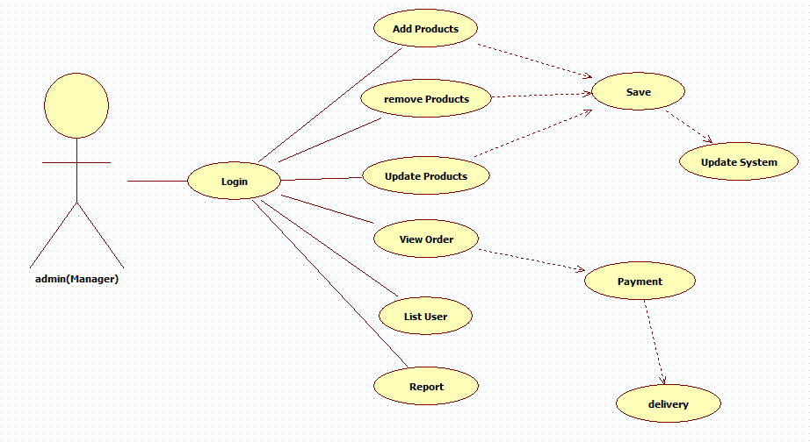

* 1. User (Customer) – use case diagram

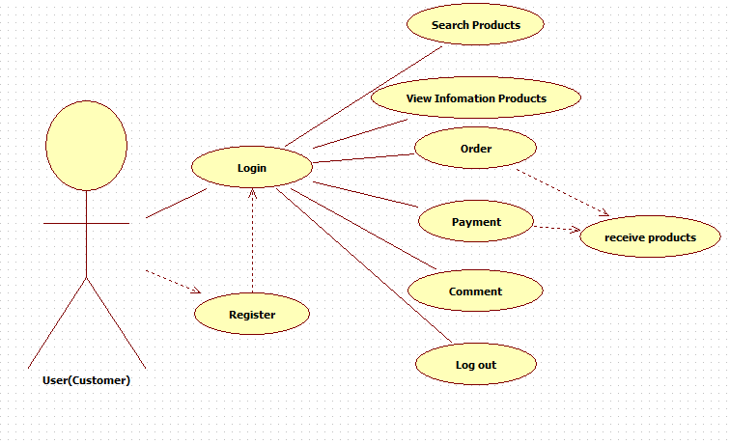

1. System pages flow

